 **Hong Kong Institute of Vocational Education**

**ITP4506 Human Computer Interaction and GUI Programming**

**E-commerce Website**

|  |  |  |  |
| --- | --- | --- | --- |
| **Student ID** | **Name** | **Contribution** | **Signature** |
| 160450066 | LamKitYu | 50% |  |
| 160548082 | YauTsunSing | 50% |  |

Table of Contents

1. Background 1

2. User Analysis 2

2.1. User characteristics 2

2.1.1. Learning style 2

2.1.2. Tool preferences 2

2.1.3. Physical differences 3

2.1.4. Cultural differences 3

2.1.5. Knowledge of job 3

2.1.6. Application familiarity 3

2.1.7. Primary and secondary users 4

2.2. Techniques for observing and listening to users 4

2.2.1. Focus groups 4

2.3. Environment Analysis 4

2.4. Recruiting Users 4

2.5. Task Analysis (HTA) 5

2.5.1. Hierarchical Task Analysis – Register an account 5

2.5.2. Hierarchical Task Analysis – Login an account 6

2.5.3. Hierarchical Task Analysis – Book a Flight 7

2.5.4. Hierarchical Task Analysis – Book a Hotel 8

2.5.5. Hierarchical Task Analysis – Payment 9

2.5.2. Use case 10

3. Web Concept 11

3.1. User Interface design 11

3.1.1. Home Page 11

3.1.2. Hotel page 12

3.1.3. Flight page 13

3.1.4. Register/Login Page 14

3.1.5. Shopping cart page 15

3.1.6. Payment Page 16

3.1.7. Profile Page 17

4.1. Function 18

4.1.1. Register / Login 18

4.1.2. Search and view product 19

4.1.3. Add product to shopping cart 20

4.1.4. Check out and payment 20

1. Background

The Happy Travel Ltd is a medium-sized travel agent. This company want to build a website for the tertiary student in Hong Kong. First, the website user interface should be user-friendly. Also, the website should be provide the search function for user searching the items. Moreover, it should be offer the hotel and flight function for user choosing. In addition, the website should be provide a shopping cart, let the user add the item to the cart. Furthermore, it would be having a membership system for user since they need to login to get a discount.

1. User Analysis
   1. User characteristics
      1. Learning style

The website is target on the student so the user have a high learning skills to use the website. The users’ habits of learning are read manual. The student will go to website first, they will see what is the information will show on the website. After they read the website, they can easy to use it. The user enter the website, they will see the photo 1. They enter this website because the want to search or buy the flight ticket or book the hotel. They can click the item on the top menu. It design can let the user easily to read the first page content.

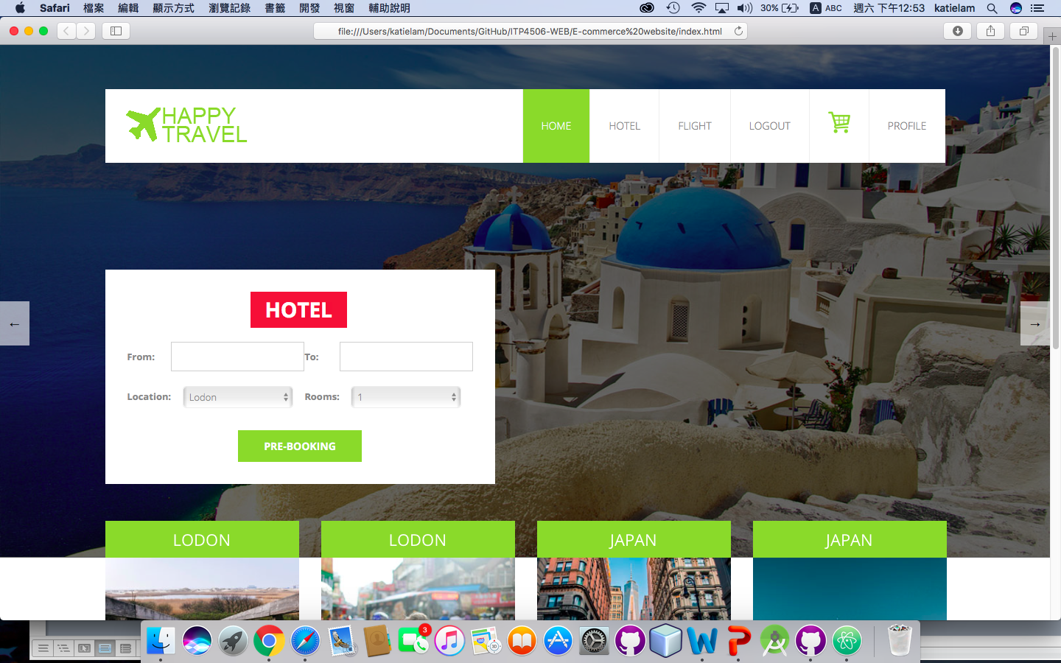(Photo 1)

* + 1. Tool preferences

For the student, they want a quick search function and an attractive user interface. It is because student like trendy style and convenient website to easy to use. So the website will provide the search engines, menu and slide show. For the search engines, the website is used the flexible box to include the search item. The user can select the date from the date picker, location, number of room and number of people are also is drop-down menu. When they click the input box, it will pop up the drop down menu or date picker. It is no need to enter the information. The user chooses it only. For the menu, the website is clearly to set the name of the menu. Also, the shopping cart uses a cart logo to present it. Using photo can easy to show the meaning. For the slideshow, the slideshow both side have a button of changing. That can show to user the slide have another information.

* + 1. Physical differences

Abilities among different people may be different but this website is target on the tertiary student. So the age is around 18-30. Also, the target group has men and female. Furthermore, considering of the vision limitations such as color blindness so the website would be set the color of green, white and grey of main color. The font sizes are not too large and too small. The title set to 18px. The content may set 14-16px.

|  |  |
| --- | --- |
| **Font sizes (Title)** | 18px |
| **Font sizes (content)** | 14-16px |
| **Main color of website** | Green (#9ED034), Grey(#EEEEEE), White (#FFFFFF)  Macintosh HD:Users:katielam:Desktop:螢幕快照 2017-12-01 下午3.21.12.png Macintosh HD:Users:katielam:Desktop:螢幕快照 2017-12-01 下午3.19.12.png |

2.1.4. Cultural differences

The target customer is the tertiary student so they have a higher education level. Also, the reading level is also higher. For the website using vocabularies, the user also can understand the meaning and they no need to check the dictionary. The website language could use English.

### 2.1.5. Knowledge of job

For the travel agent is using specialized vocabularies. For example, customer service, booking, flight, hotel, deals, available, main amenities etc.

* + 1. Application familiarity

For the novice, they need to a guideline to follow the step-by-step using the website.

About the Expert, they no need a guideline to follow the step-by-step using the website. They can learn

* + 1. Primary and secondary users

|  |  |
| --- | --- |
| **Primary User** | **Secondary User** |
| Hotel reservation clerk | Customer who called the support line |
| Flight reservation clerk | Tertiary student |
| Travel agent |  |

2.2. Techniques for observing and listening to users

2.2.1. Focus groups

Regarding some students are less willing to express opinions in the public, we can do an online observation. About a group of people are asked about their perceptions, opinions, beliefs, and attitudes towards a product or service, we can search another travel agent website for our reference. It can collect some ideas for the new website for student.

2.3. Environment Analysis

The student also use the website to buy the flight ticket and hotel at home. Therefore, we need to set the color is not too bright or too dark. We should provide a comfortable interface for student. Also, the website has enough areas to show the information since the user’s computer screen is large. Moreover, we can offer a scroll to move the web page.

2.4. Recruiting Users

In the website, post notice or ask a professor to announce provide incentives, if they are do an online survey, they can get the prize. It is a good way to get the feedback when we are want to improve the website.

## 2.5. Task Analysis (HTA)

The website should be go through the 5 main function such as register an account, login an account, book a hotel, book a flight and payment. It can provide a smoothly processing for user browsing.

### 2.5.1. Hierarchical Task Analysis – Register an account

0. In order to register an account from the happy travel Ltd website

1. Go to the website

2. Find the required register an account

2.1 access website catalogue

2.2 access the register screen

2.3 enter personal information

2.4 identify required information

2.5 register the account

3. Try to login

register an account from the Happy Travel Ltd website

0

Plan 0:

Do 1 – 3

If cannot register, do 2 - 3

try to login

3

Plan 2:

Do 2.1 – 2.4 – 2.5

If hotel not identified from information available, do 2.2-2.3-2.4-2.5

register the account

2.5

identify required information

2.4

enter personal information

2.3

2.3

access the register screen

2.2

access catalog

2.1

go the Happy Travel Ltd website

1

find required register an account

2

### 2.5.2. Hierarchical Task Analysis – Login an account

0. In order to login an account from the happy travel Ltd website

1. Go to the website

2. Find the required login an account

2.1 access website catalogue

2.2 access the login screen

2.3 enter login name and password

2.4 identify required information

2.5 login the account

3. Try to login

4. Go to home page

register an account from the Happy Travel Ltd website

0

go to home page

4

Plan 0:

Do 1 – 3 - 4

If cannot register, do 2 – 3 - 4

try to login

3

Plan 2:

Do 2.1 – 2.4 – 2.5

If hotel not identified from information available, do 2.2-2.3-2.4-2.5

login the account

2.5

identify required information

2.4

enter login name and password

2.3

2.3

access the login screen

2.2

access catalog

2.1

go the Happy Travel Ltd website

1

find required login an account

2

### 2.5.3. Hierarchical Task Analysis – Book a Flight

0. In order to buy a flight ticket from the happy travel Ltd website

1. Go to the website

2. Find the required flight ticket

2.1 access website catalogue

2.2 access the search screen

2.3 enter search criteria

2.4 identify required flight ticket

2.5 note the flight

3. Add to shopping cart

4. Go to shopping cart to check out

5. Fill in all the information to pay

Book a flight from the Happy Travel Ltd website

0

Plan 0:

Do 1 – 3 - 4

If flight is sold out, do 2 – 3 - 4

Plan 2:

Do 2.1 – 2.4 – 2.5

If hotel not identified from information available, do 2.2-2.3-2.4-2.5

Note the flight

2.5

identify required hotel

2.4

enter search criteria

2.3

2.3

access search screen

2.2

access catalog

2.1

go the Happy Travel Ltd website

1

find required flight

2

retrieve flight from list

3

choose flight to add to shopping cart

4

### 2.5.4. Hierarchical Task Analysis – Book a Hotel

0. In order to book a hotel from the happy travel Ltd website

1. Go to the website

2. Find the required hotel

2.1 access website catalogue

2.2 access the search screen

2.3 enter search criteria

2.4 identify required hotel

2.5 note the hotel

3. Add to shopping cart

4. Go to shopping cart to check out

5. Fill in all the information to pay

Book a hotel from the Happy Travel Ltd website

0

Plan 0:

Do 1 – 3 - 4

If hotel is sold out, do 2 – 3 - 4

Plan 2:

Do 2.1 – 2.4 – 2.5

If hotel not identified from information available, do 2.2-2.3-2.4-2.5

Note the hotel

2.5

identify required hotel

2.4

enter search criteria

2.3

2.3

access search screen

2.2

access catalog

2.1

go the Happy Travel Ltd website

1

find required hotel

2

retrieve hotel from list

3

choose hotel to add to shopping cart

4

### 2.5.5. Hierarchical Task Analysis – Payment

0. In order to pay the order flight/hotel from the happy travel Ltd website

1. Go to the website

2. Go to the shopping cart

3. Find the required Payment

3.1 access the payment

3.2 login to get a discount

3.3 enter payment information criteria

3.4 identify required information

3.5 order the hotel flight

4. Successful Payment

5. Go back to home page

Pay a payment from the Happy Travel Ltd website

0

Plan 3:

If not login, Do 3.1 – 3.2 – 3.3 – 3.4 – 3.5

If login, Do 3.1 – 3.3 – 3.4 – 3.5

If hotel not identified from information available, do 3.2 – 3.3 – 3.4 – 3.5

access payment

3.1

login to get a discount

3.2

enter payment information criteria

3.3

3.3

2.3

identify required information

3.4

order the hotel flight

3.5

2.3

go the Happy Travel Ltd website

1

go to the shopping cart

2

find the required Payment

3

3

go back to home page

4

### 2.5.2. Use case

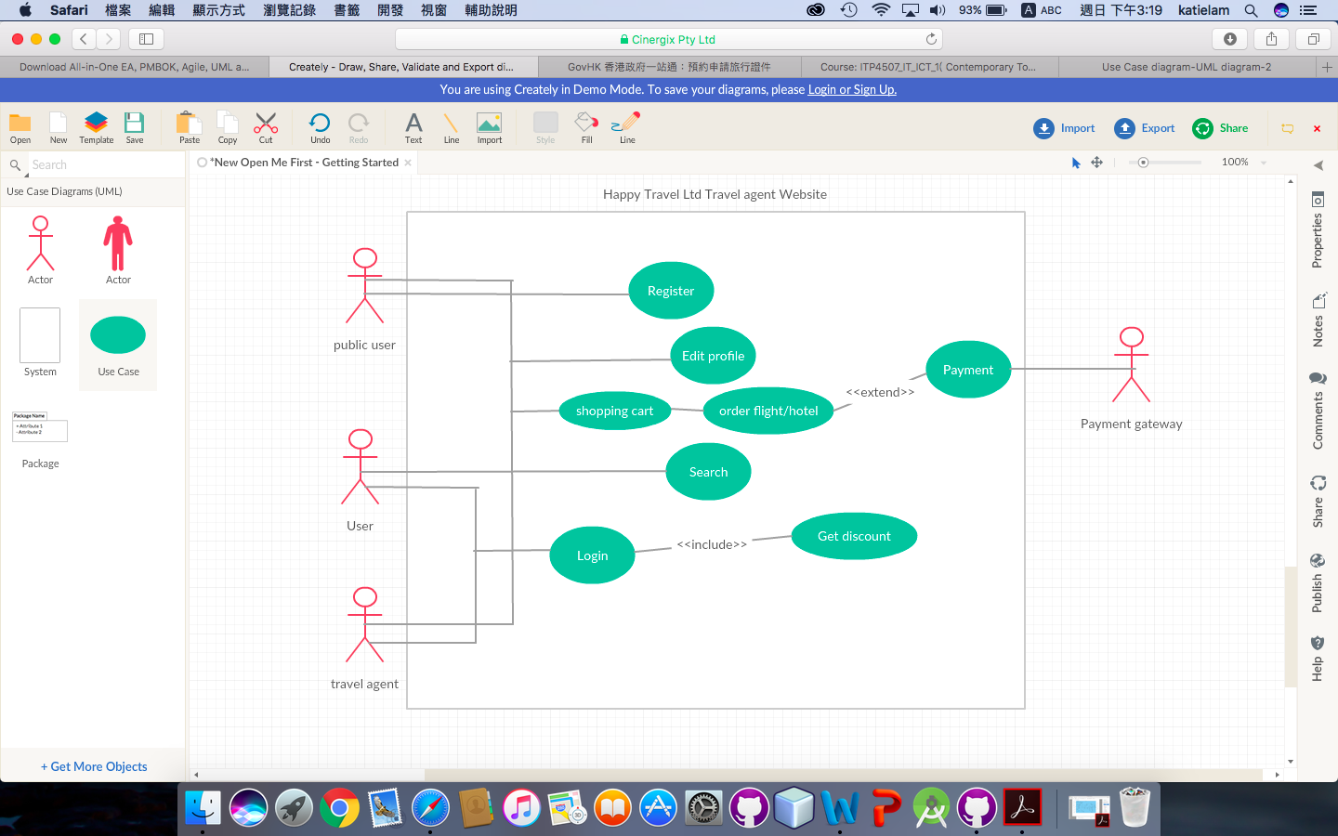

1. Web Concept

3.1. User Interface design

3.1.1. Home Page



header

|  |  |
| --- | --- |
| **Design Principles** | **Description** |
| **Mental Model** | Arrow logo: move left or right to next item |
| **Affordance** | 1. Slide search box provide search function,  2. Arrow can move the slide (left or right)  3. Menu of each category can go to the relative page |
| **Content Organization -**  **Chronological** | Header: menu for grouping the name of relative page and  search function (hotel or flight)  Body: grouping the package of flight and hotel suggestion  Footer: grouping the logo |
| **Visual Organization –**  **Consistent** | After change to next page, the next content will show on body only. |
| **Navigation** | Search engines: Slide box for searching hotel/flight  Global - Hyperlinks: menu bar |

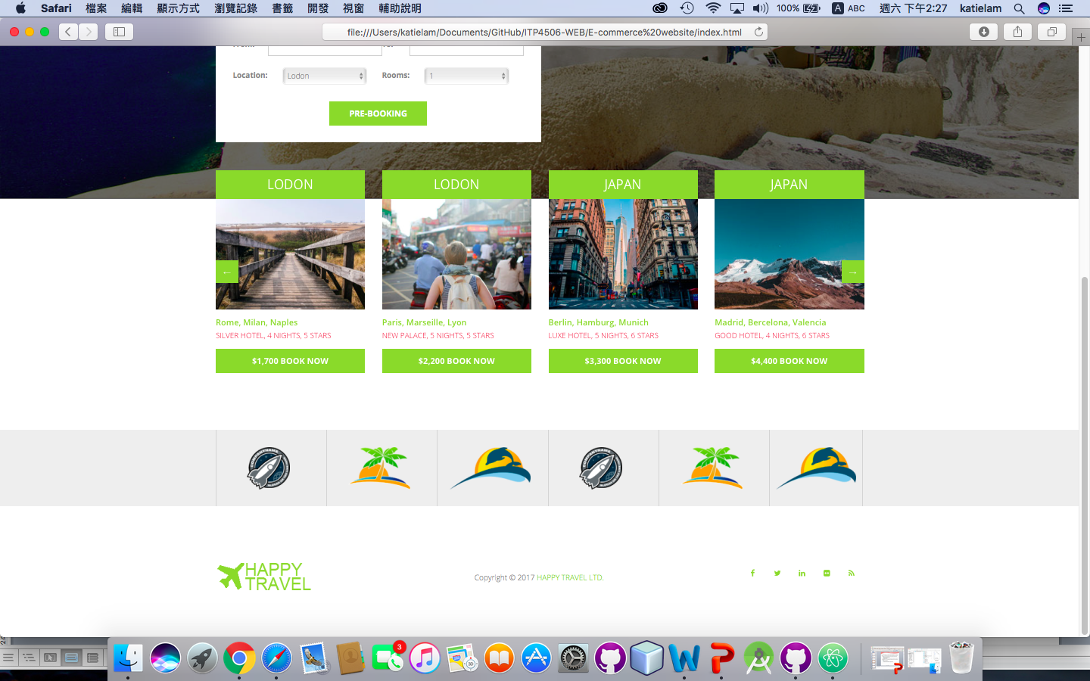

body

footer

3.1.2. Hotel page

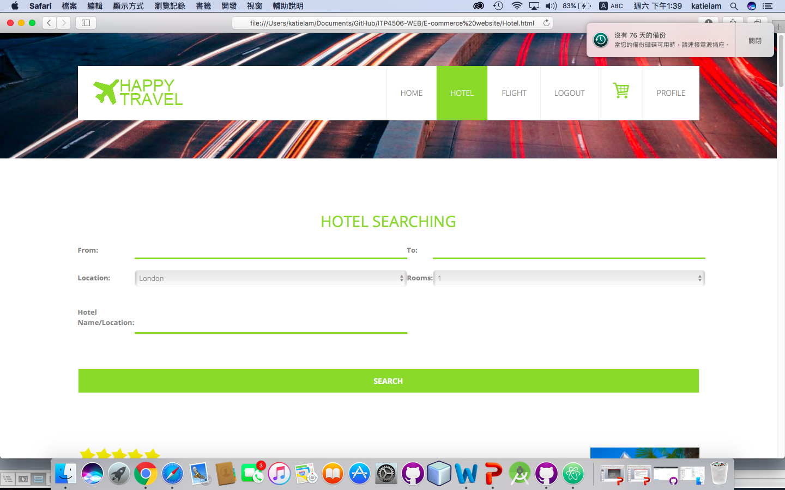

header

body

|  |  |
| --- | --- |
| **Design Principles** | **Description** |
| **Mental Model** | Scroll: move up and down |
| **Affordance** | 1.Input box for searching hotel function,  2.drop down list to change the location for searching  3.button add the item to shopping cart |
| **Content Organization -**  **Chronological** | Header: menu for grouping the name of relative page  Body: Grouping the hotel of the list view |
| **Visual Organization**  **– Consistency** | 1. list view of grouping the hotel  2.All searching input type grouping together |
| **Navigation** | Search engines: form for searching hotel  Global - Hyperlinks: menu bar |

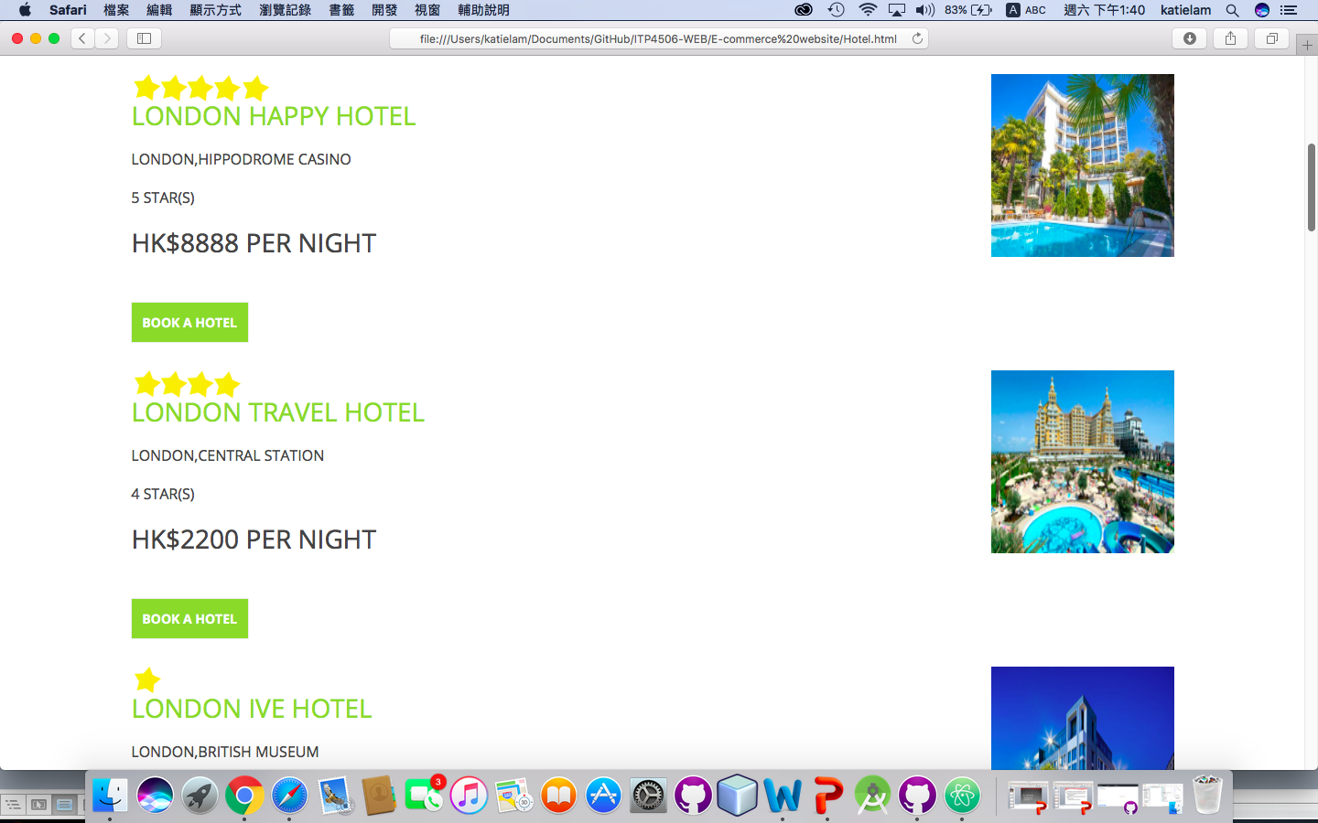

|  |  |
| --- | --- |
| **Design Principles** | **Description** |
| **Mental Model** | Scroll: move up and down |
| **Affordance** | 1.Input box for searching flight ticket function  2.button add the item to shopping cart |
| **Content Organization -**  **Chronological** | Header: menu for grouping the name of relative page  Body: Grouping the flight ticket of the list view |
| **Visual Organization – Consistency** | 1. List view of grouping the flight ticket  2.All searching input type grouping together |
| **Navigation** | Search engines: form for searching hotel  Global - Hyperlinks: menu bar |

3.1.3. Flight page

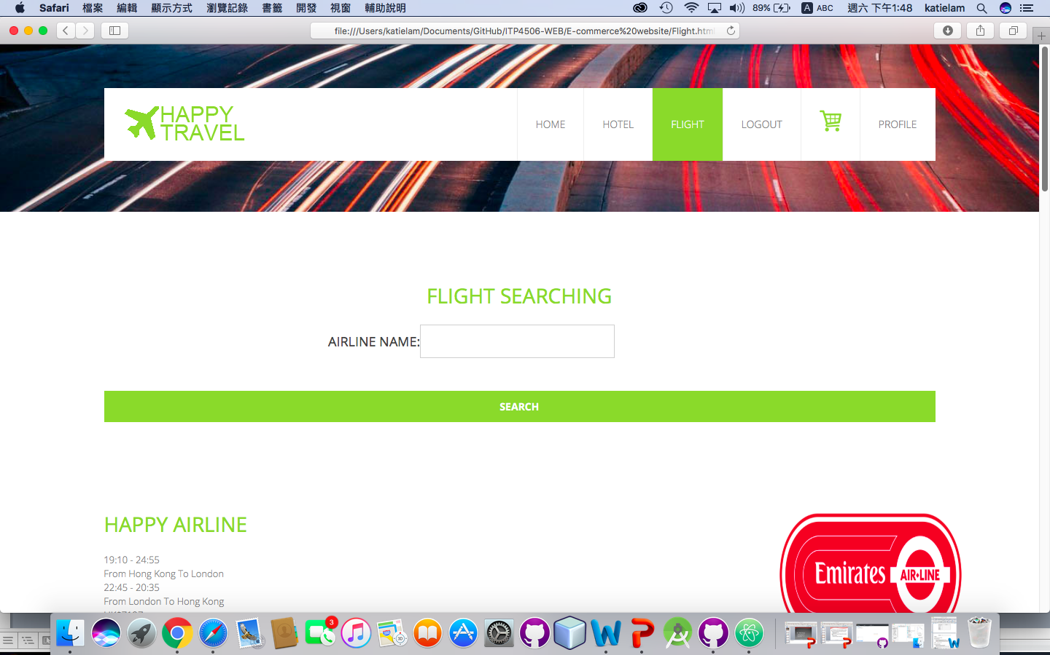

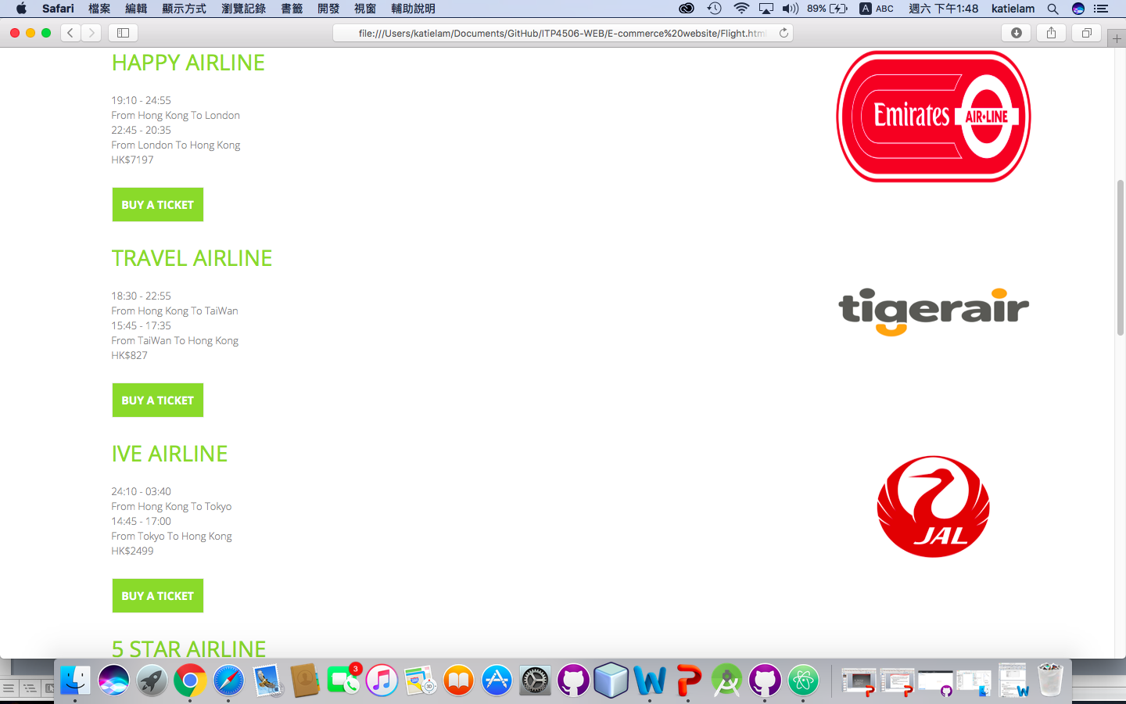

Body

3.1.4. Register/Login Page

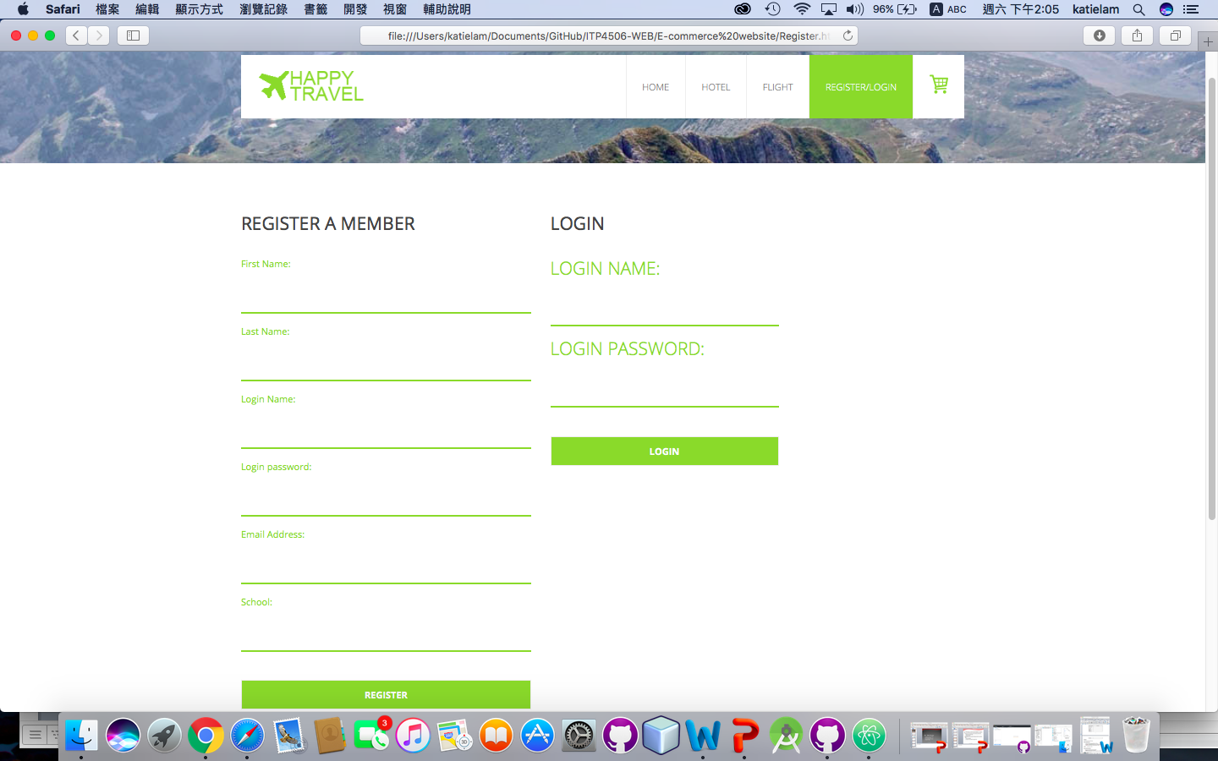

body

header

|  |  |
| --- | --- |
| **Design Principles** | **Description** |
| **Mental Model** | scroll: move up and down |
| **Affordance** | 1.Register form of input box can be entering the personal information.  2. Register form of button can be submitting the personal information.  3. Login form of input box can be entering the login name and password.  4. Login form of button can be login account |
| **Content Organization -**  **Chronological** | Header: menu for grouping the name of relative page  Body: Grouping Register form and login form separate |
| **Visual Organization– Consistency** | 1.From of grouping the register / Login |
| **Navigation** | Global - Hyperlinks: menu bar |

3.1.5. Shopping cart page

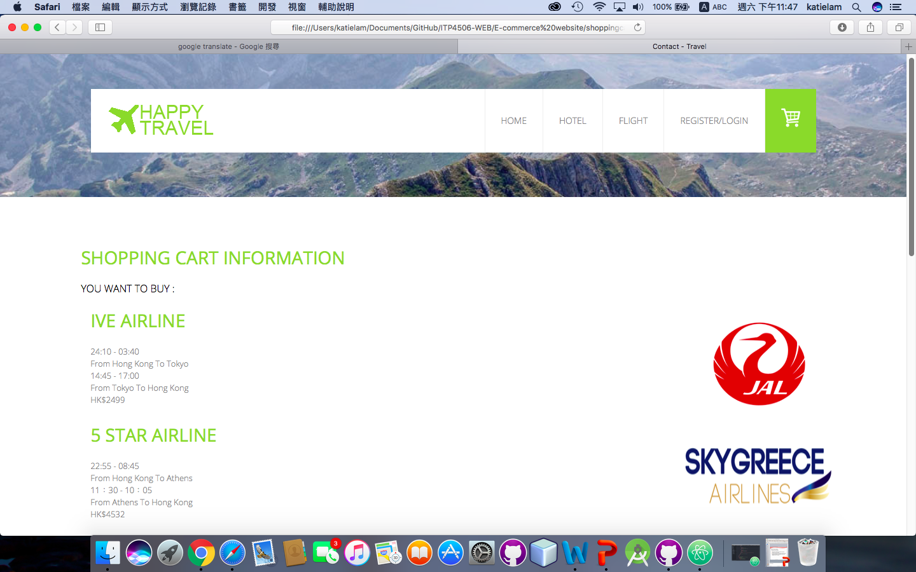

Header

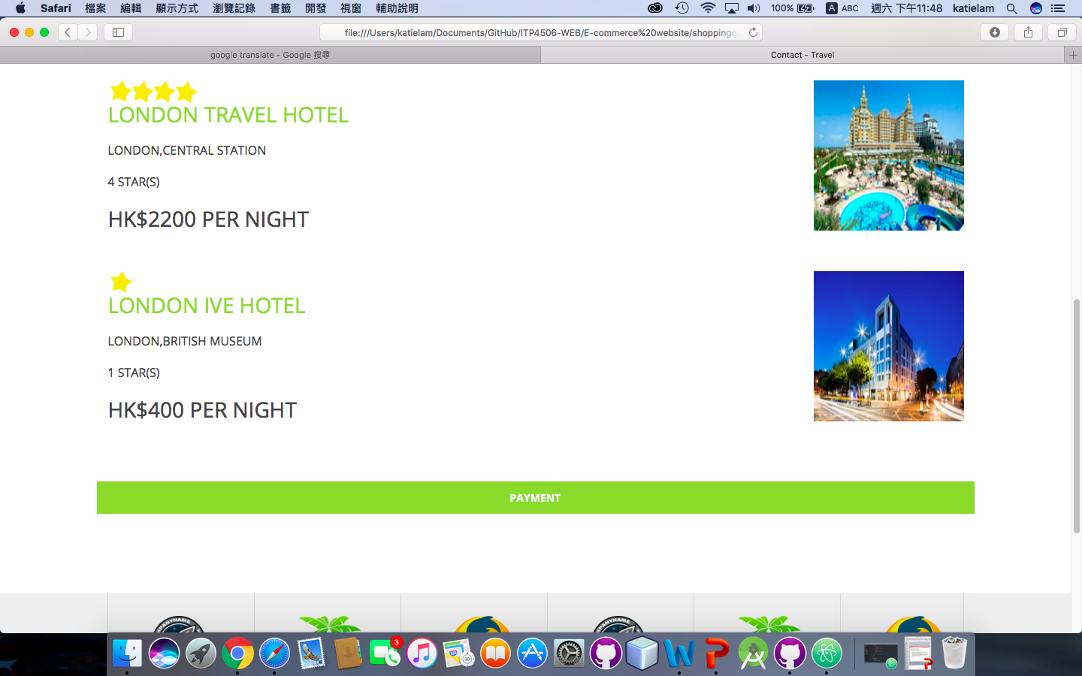

|  |  |
| --- | --- |
| **Design Principles** | **Description** |
| **Mental Model** | Scroll: move up and down |
| **Affordance** | “Payment” button for link to the payment page |
| **Content Organization-**  **Chronological** | Header: menu for grouping the name of relative page  Body: list view of shopping cart |
| **Visual Organization– Consistency** | 1. Click the “Payment” button will go to payment page |
| **Navigation** | Global - Hyperlinks: menu bar |

3.1.6. Payment Page

|  |  |
| --- | --- |
| **Design Principles** | **Description** |
| **Mental Model** | Scroll: move up and down |
| **Affordance** | 1.“Login” button will link to login page  2.“Pay now” button will check all information and go to payment gateway to check.  3.“Add your personal information” button will fill in the personal information into input box |
| **Content Organization-**  **Chronological** | Header: menu for grouping the name of relative page  Body: Grouping all relative payment in form |
| **Visual Organization– Consistency** | 1. All related payment information is grouping in form. |
| **Navigation** | Global - Hyperlinks: menu bar |

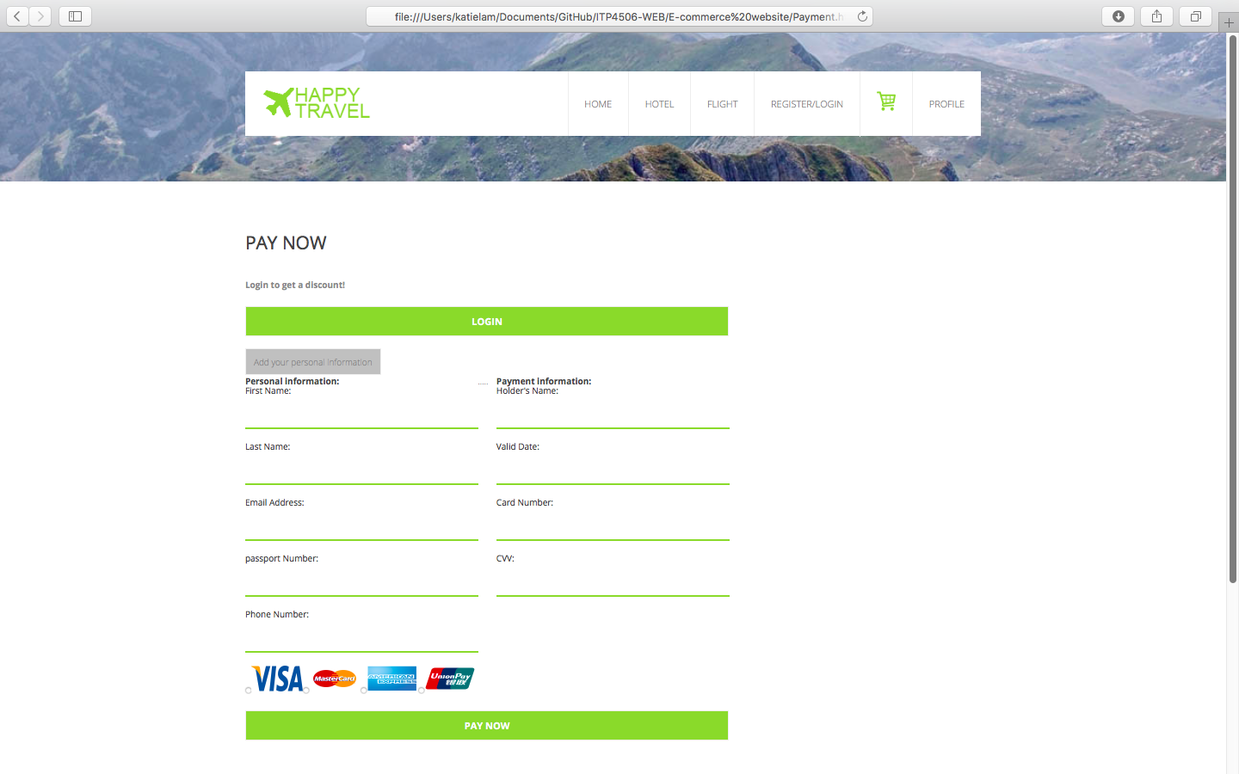

Header

Body

3.1.7. Profile Page

|  |  |
| --- | --- |
| **Design Principles** | **Description** |
| **Mental Model** | Scroll: move up and down |
| **Affordance** | Input box |
| **Content Organization-**  **Chronological** | Header: menu for grouping the name of relative page  Body: All personal information |
| **Visual Organization– Consistency** | 1. You can see your personal information here. |
| **Navigation** | Global - Hyperlinks: menu bar |

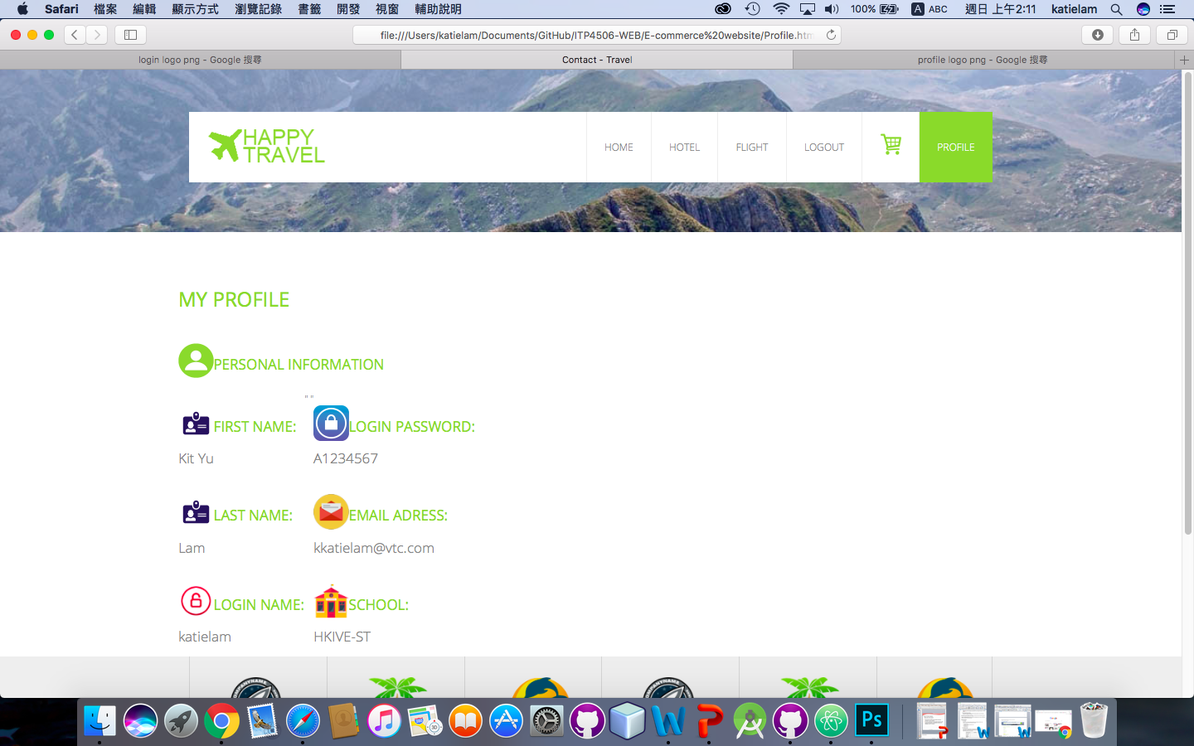

Header

Body

4.1. Function

4.1.1. Register / Login

1. Fill in all input box.

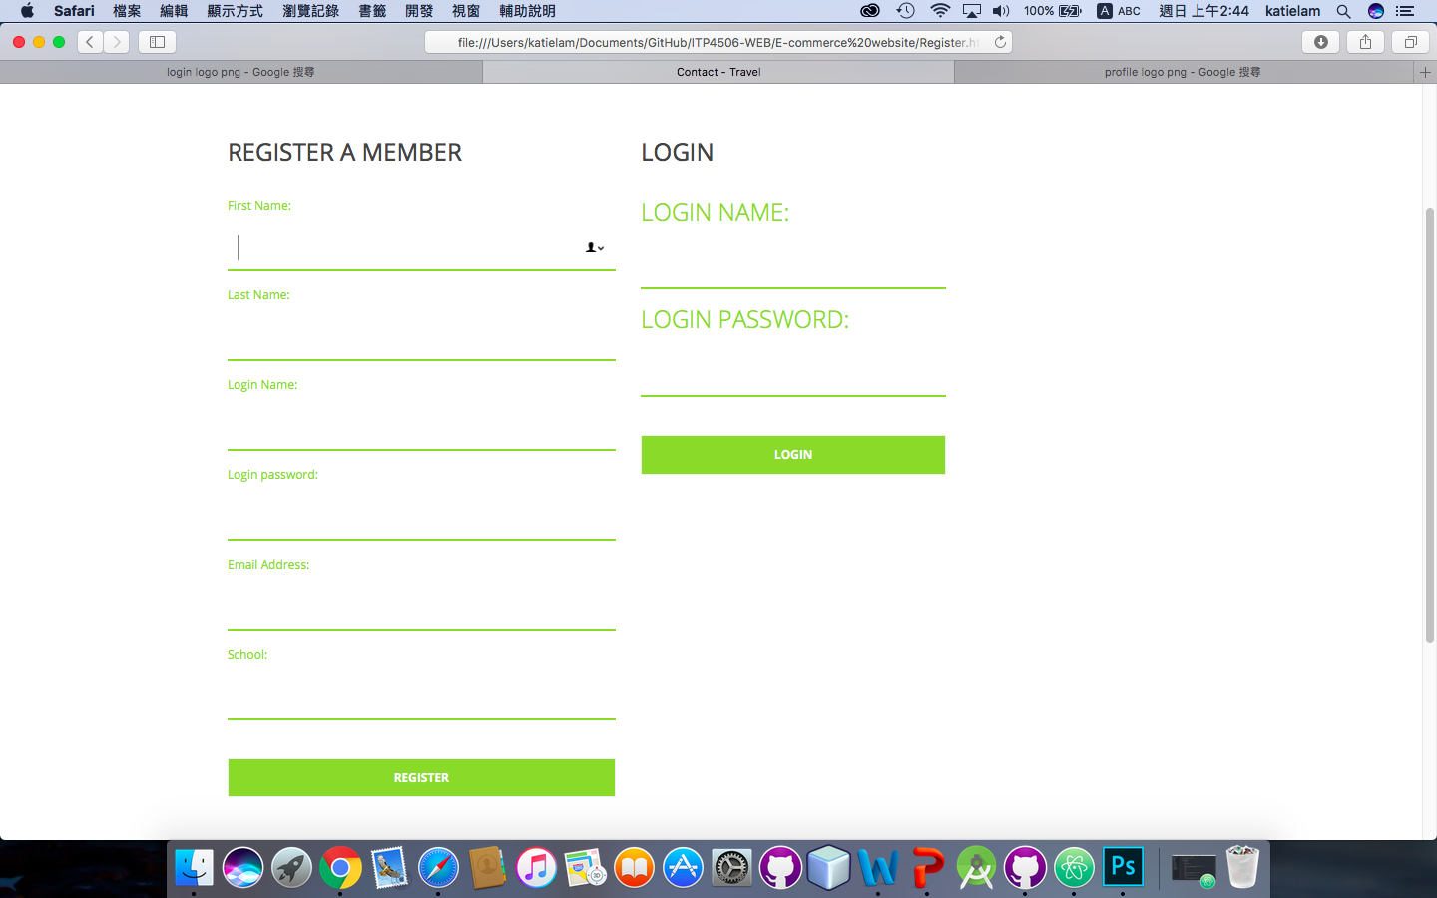

2. Click “Register” button



3.Pop-up the Modal box

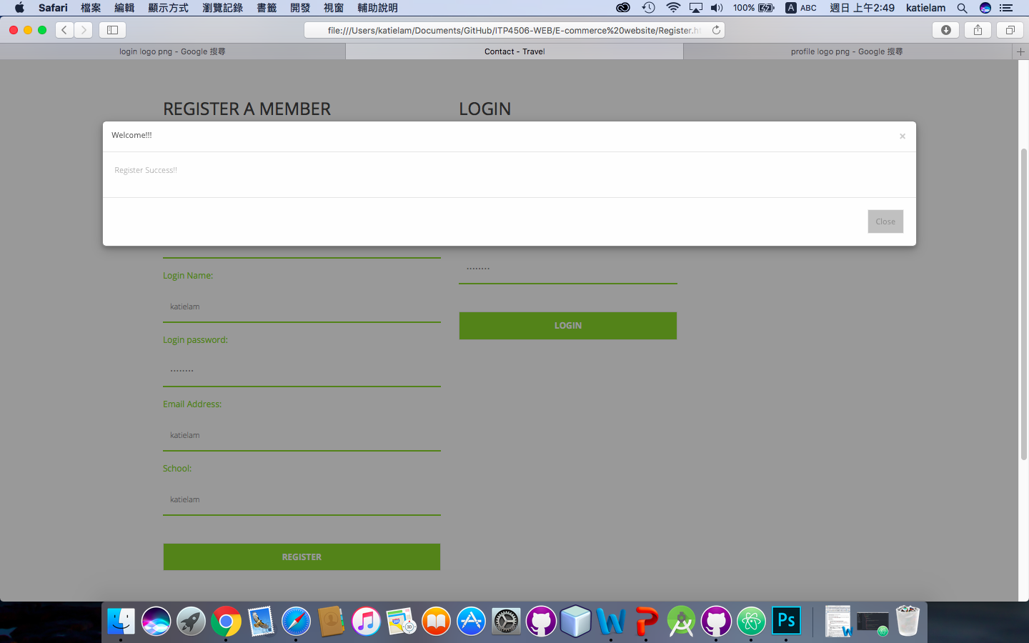

4. Input the login name and login password.

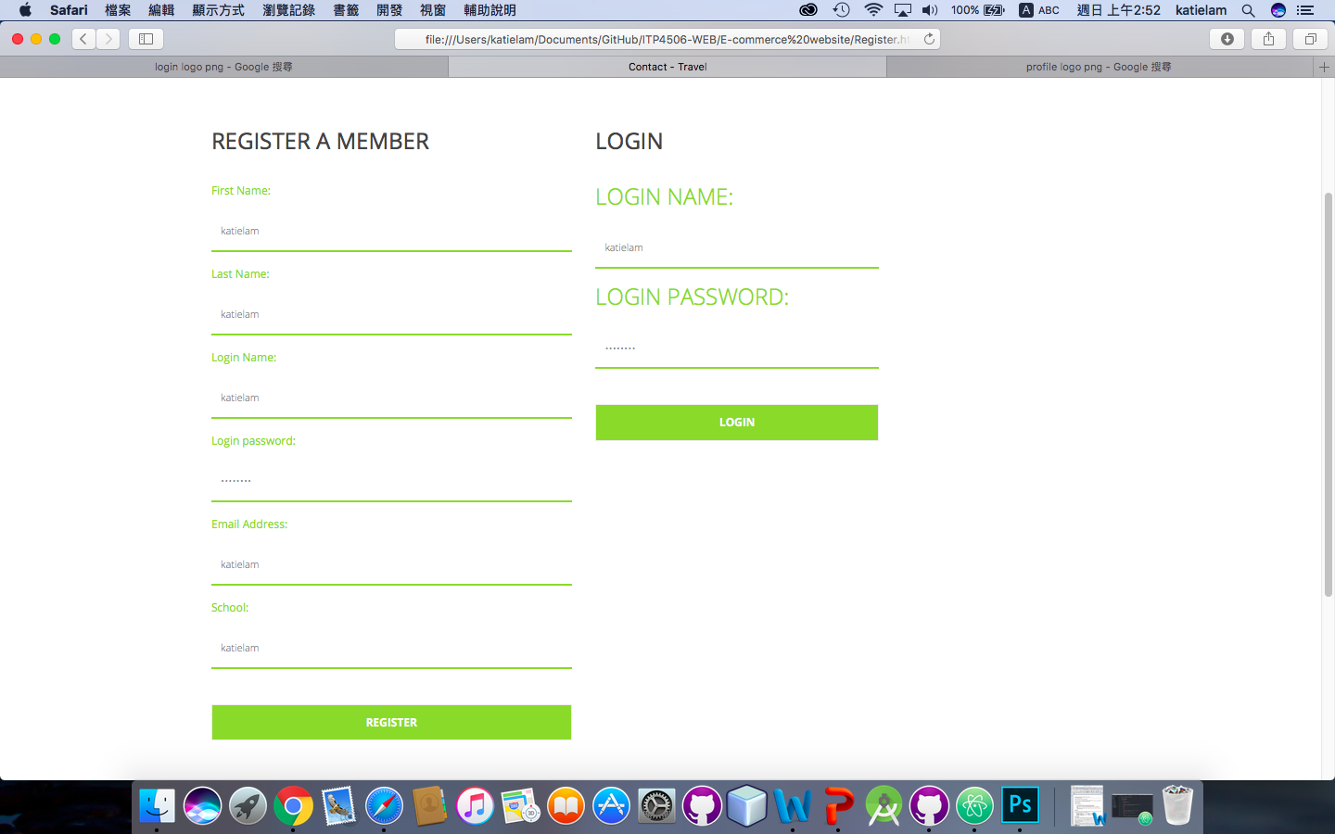

5. Click “Login” button

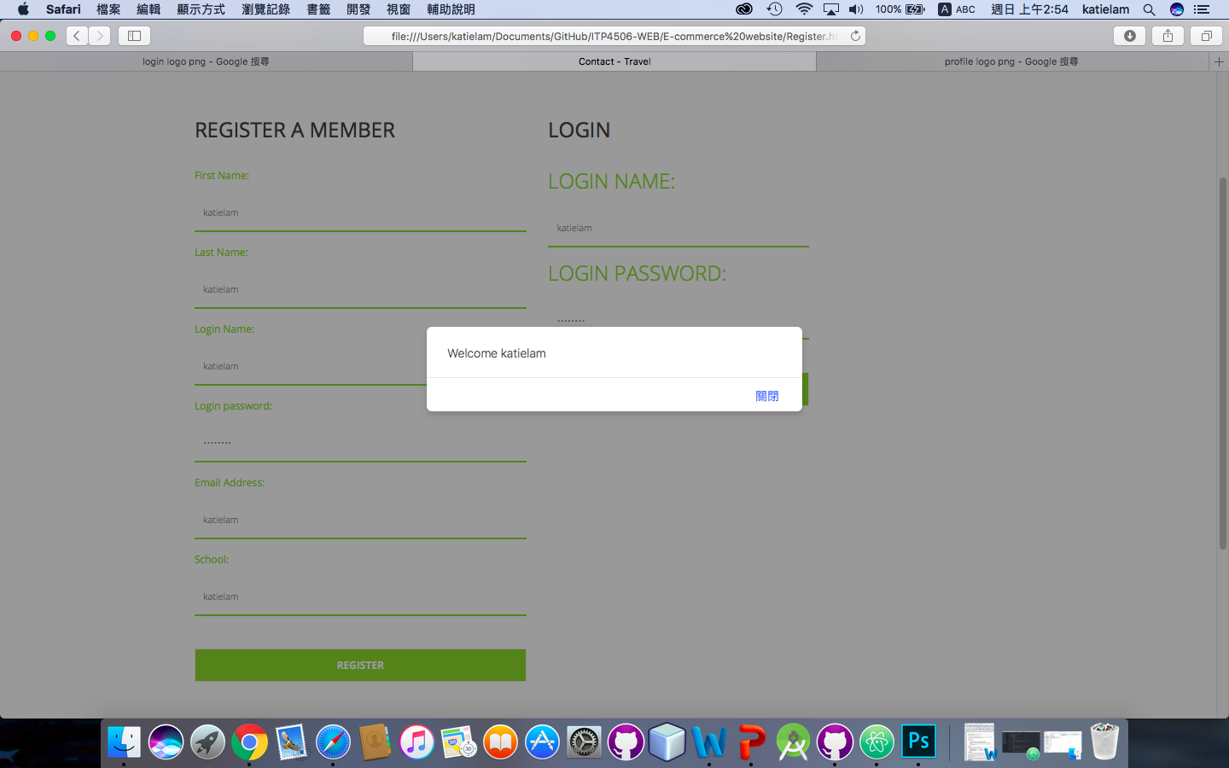

4.1.2. Search and view product

1. In home page, you can see hotel/flight box

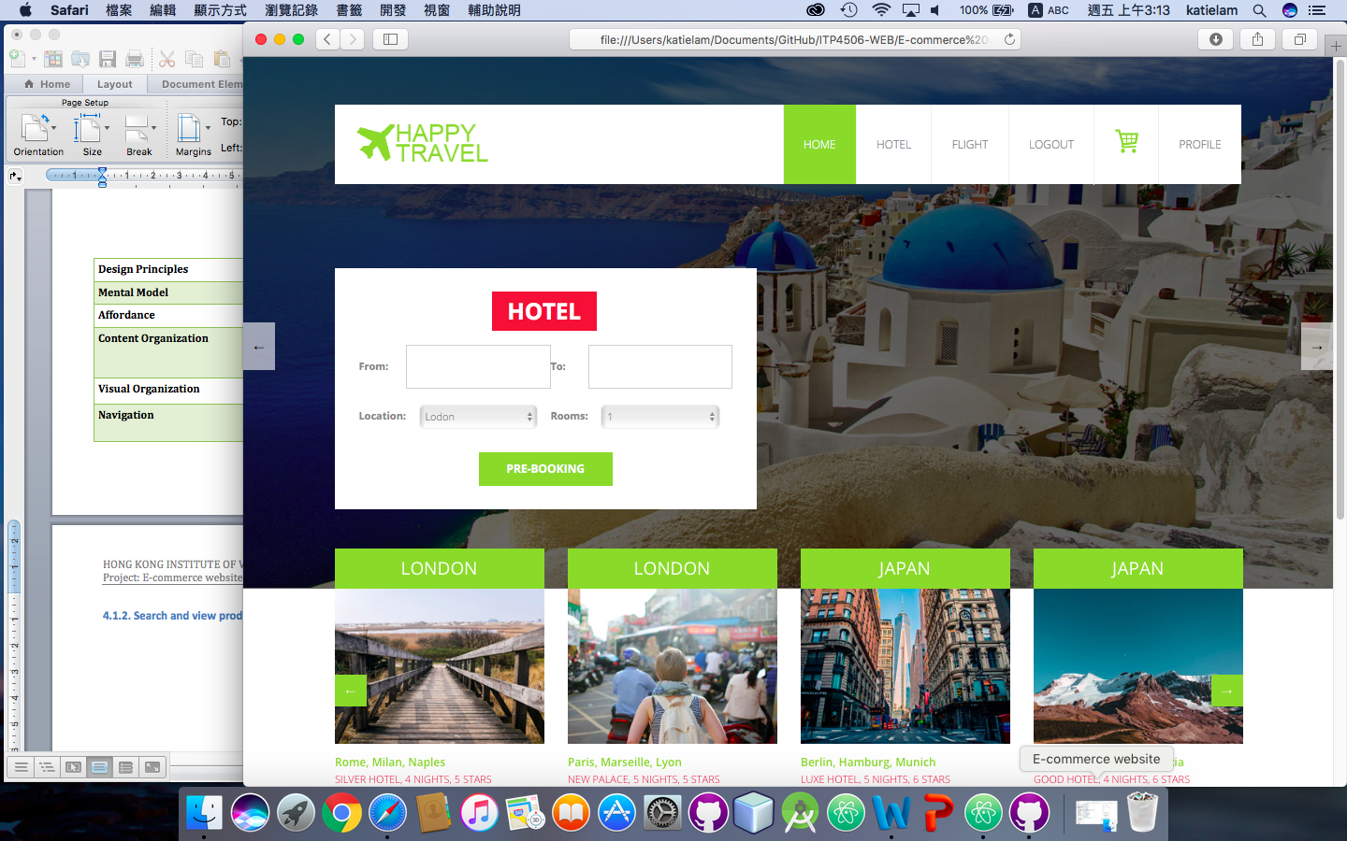

2. Enter the criteria in the box



3. Click the “PRE_BOOKING” button



1. Go to the flight/hotel page
2. View the list under the search function

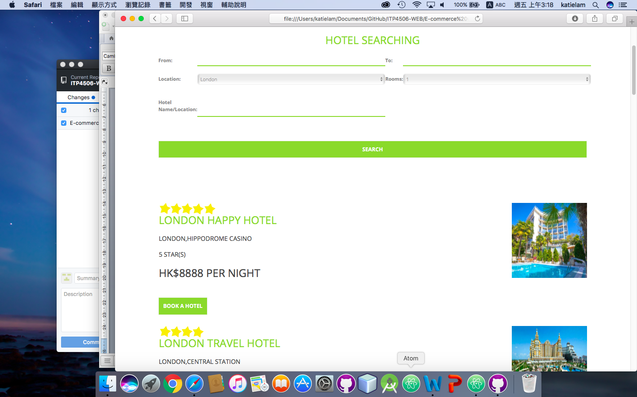

4.1.3. Add product to shopping cart

1. Click Flight/Hotel in menu



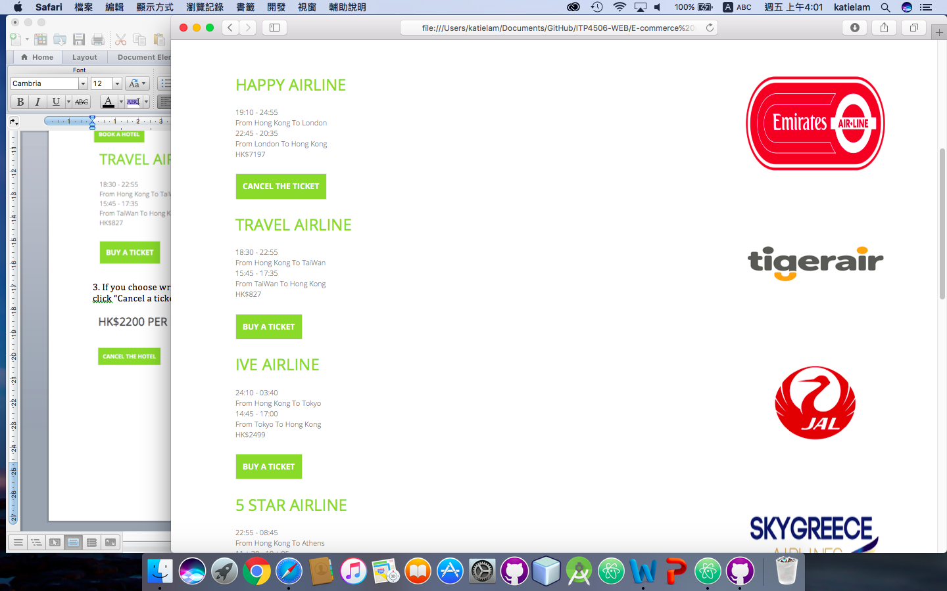

2. Click “Book a hotel” / “Book a flight”

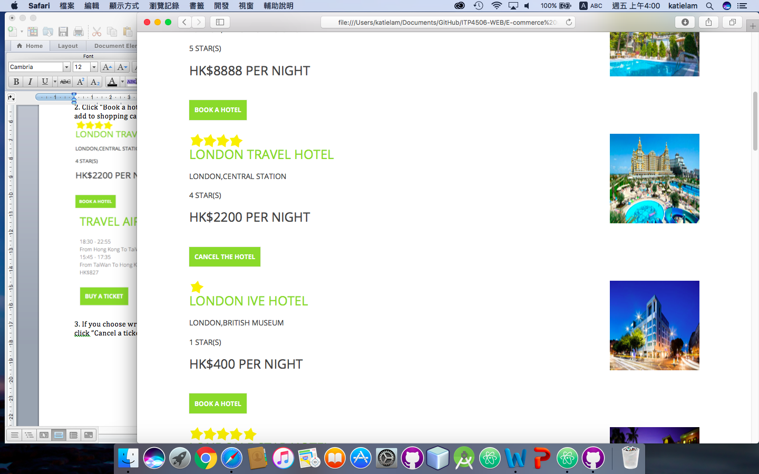

3. Cancel the chosen one, Click “Cancel a hotel” / “Cancel a ticket”



## 4.1.4. Check out and payment

1. Click “Cart” icon in the menu



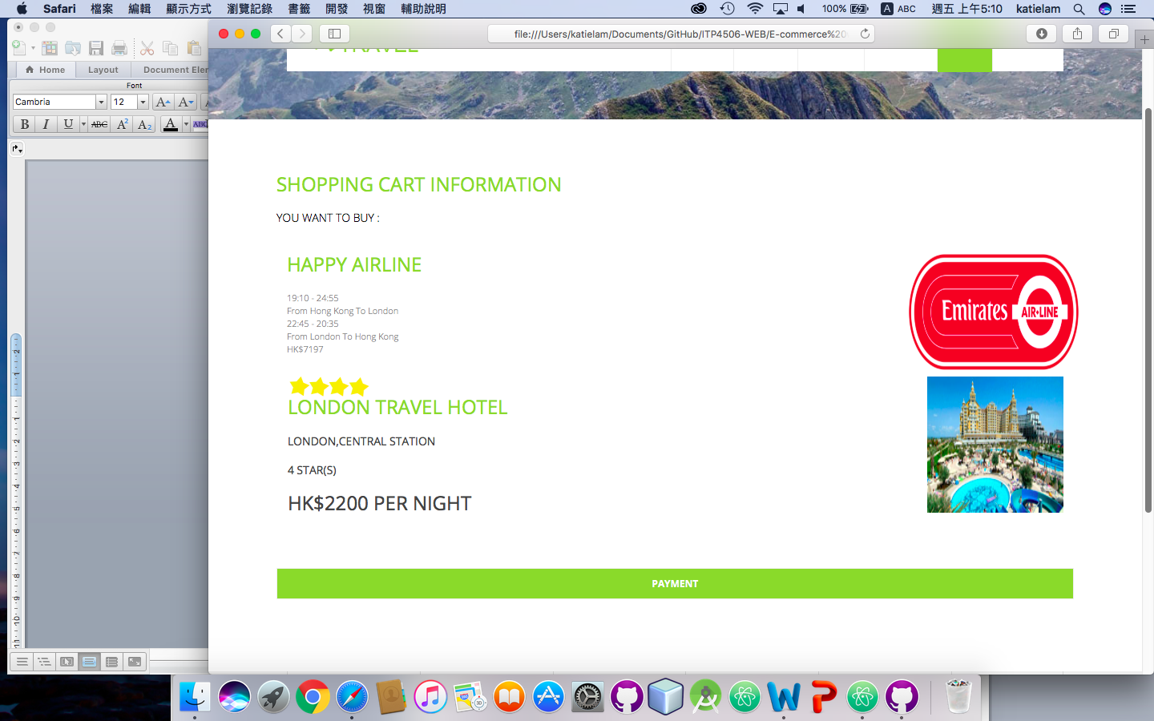

2. Click “Payment” button



3. Fill in all the information

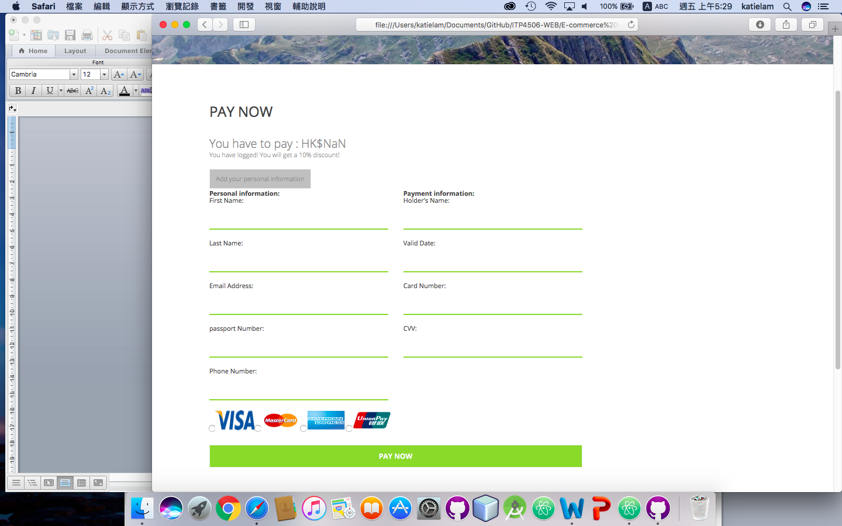

4. Click “Pay now” to finish your order